Efficient One-Pot Synthesis of 1,4-Dihydropyridine and Polyhydroquinoline Derivatives using Sulfanilic acid-functionalized boehmite nano-particles as an organic-inorganic hybrid catalyst
Mohammad Reza Khodabakhshi ª , Mostafa Kiamehr ^{b}, Ramin Karimian ^{c}
ª Applied Biotechnology Research Center, Baqiyatallah University of Medical Sciences, Tehran, Iran. E-mail: Khodabakhshi2002@gmail.com
^{b} Department of Chemistry, Faculty of Science, University of Qom, Ghadir Blvd, P. O. Box 37146-6611, Qom, Iran
^{c} Chemical Injuries Research Center, Systems Biology and poisonings institute, Baqiyatallah University of Medical Sciences, Tehran Iran

Experimental section
General Information……………………………………………………………….………….S3
General procedure for preparation of the BNPs………………………………….…………S3
General procedure for preparation of the BNPs@Si(CH₂)₃@NHSO₃H...............................S3
General procedure for the preparation of 1,4-dihydropyridine and polyhydroquinoline derivatives……………………………………………………………………………………....S3
Chemical characterization of BNPs@Si(CH₂)₃@NHSO₃H.....................................................S4
HNMR spectral data of compounds…………………………………………………………..S7
¹HNMR and FTIR 5b…………..……………………………………………………………...S7
¹HNMR and FTIR 5d..…………...….………...……………………………………….………S7

Experimental section

General Informations:
All Chemical Reagents and solvents were purchased from Merck and Aldrich companies. Melting points of the samples were measured by using an electrothermal 9100 device and are unmodified. Characterization of the catalyst 1 done with FESEM TESCAN-MIRA3, EDX Numerix DXP-X10P, Shimadzu FT-IR-8400S, TGA Bahr company STA 504 and X-ray diffraction (XRD). Analytical thin layer chromatography (TLC) was done using Merck 0.2 mm silica gel 60 F-254 Al-plates for supervision of reactions. FTIR spectra were registered as KBr pills on a Shimadzu FT IR-8400S spectrometer. 1H NMR (500 MHz) spectra were registered on a Bruker DRX-500 Avance spectrometers in DMSO, as solvent, at surroundings temperature.

General procedure for preparation of the BNPs:
To the solution obtained from NaOH (6.40 g) and deionized water (50 ml), solution of Al(NO₃)₃⋅9H₂O (20 g) in of deionized water (200 ml) drop by drop added with stirring. The cream-colored mixture obtained from the previous step was mixed in an ultrasonic bath at 25°C for 3 hours. The synthesized BNPs were filtered and washed with deionized water and dried at 220°C for 4 hours.

General procedure for preparation of the BNPs@Si(CH₂)₃@NHSO₃H:
To synthesize the nanocatalyst BNPs@Si(CH₂)₃@NHSO₃H, BNPs (1 g) were refluxed with chloropropyl trimethoxysilane (CPTMOS) (2 ml) in dry toluene (30 ml) for 24 hours (Scheme 3). Functional BNPs with chloropropyl trimethoxysilane is a white solid, washed with dry toluene and n-hexane, and dried at 100 ºC for 24 hours. Then Cl-BNPs (1 g) were refluxed with sulfanilic acid (0.8 g) in dry toluene (30 ml) for 48 hours (Scheme 3) to replace the terminal chlorine atoms. Then, at 6-hour intervals, trimethylamine (1.2 ml) was added to the reflux solution to replace the chlorhexidine atom. Finally, the sulfanilic acid functionalized BNPs were filtered, washed with toluene and ethanol, and dried at 100 ºC for 24 hours.

General procedure for the preparation of 1,4-dihydropyridine and polyhydroquinoline derivatives:
In a 10 mL round-bottom flask, a mixture of aryl aldehyde (1 mmol), ammonium acetate (2 mmol), ethyl acetoacetate/5,5-dimethyl-1,3-cyclohexanedione (1 mmol), and BNPs@Si (CH₂)₃@NHSO₃H (0.1 g) and ethanol (3 ml) the was stirred at reflux conditions. After the reaction, which was observed by the TLC, was completed, the reaction mixture was cooled and then filtered to separate the nanocatalyst. Ethanol solvent evaporated, which resulted in the formation of precipitates of 1,4 dihydropyridine and polyhydroquinoline derivatives. The precipitate formed was washed with n-hexane or petroleum ether to remove the remaining raw material and then dried. Synthesized products were confirmed by 1HNMR analysis.

Chemical characterization of BNPs@Si(CH₂)₃@NHSO₃H:
The FT-IR spectrum for BNPs (a), BNPs@Si(CH₂)₃@NH SO₃H (b) are shown in Fig 1. FT-IR spectrum of BNPs, strong bands in 3086 and 3308 cm⁻¹ which is assigned to the O-H bonds in surface BNPs. Several bands in the FT-IR range of BNPs at 480, 605 and 735 cm⁻¹ are assigned to Al-O groups. Moreover, the bands at 1164 and 1069 cm⁻¹ related to the hydrogen bands of OH…OH surface (Fig 1). Sulfanilic acid has several N-H tensile and bending vibration bands in the IR spectrum in the areas of 3300-3400 and 1070 cm⁻¹. In addition, in BNPs@Si(CH₂)₃@NHSO₃H, vibrations peaks in the range 1500 cm⁻¹ be attributed to C=C groups The vibration bands at 1049 cm⁻¹ region are related to the symmetric stretching of S = O, and the bands at 1149 cm⁻¹ are related to the asymmetric stretching S = O. Also, the vibration bands at 1413 cm⁻¹ are related to the asymmetric stretching of the SO₃H groups (Fig 1b). Fig.1c belongs to the recycled catalyst. The presence of indicator peaks in the recycled catalyst indicates the good stability of the synthesized catalyst.

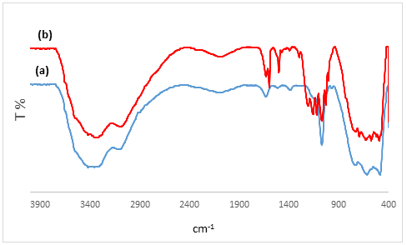

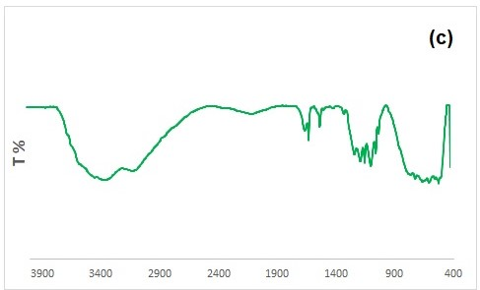
Fig 1. FT-IR spectra of (a) BNPs (b) BNPs @Si(CH₂)₃@NHSO₃H (c) recycled catalyst

FESEM images show the morphology of the surface and particle size of the nanocatalyst made. As shown in Figs. 2, The synthesized nanocatalyst has uniform distribution particles with a particle size of about 30 nm, which can be seen in the particle size dispensation diagram. The image represents uniform distribution of the particle size in the present of nanocatalyst.

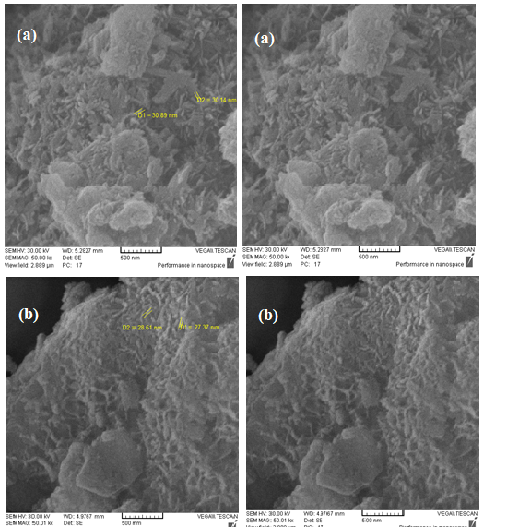
Fig. 2. SEM image of BNPs @ Si(CH₂)₃@NHSO₃H nanocatalyst.

BNPs@Si(CH₂)₃@NHSO₃H nanocatalyst were analyzed by thermometer analysis (TGA) (Fig.3). At temperatures below 200ºC, the observed weight loss is related to surface water disposal, while weight loss at temperatures above 400º C is related to the removal of water in the BNPs@Si(CH₂)₃@NHSO₃H structure. Furthermore, weight loss occurred at 250–300 ºC due to loss of sulfanilic acid mass and another weight loss occurred at 400–600ºC, which is related to the loss of part of the SO₃H group.

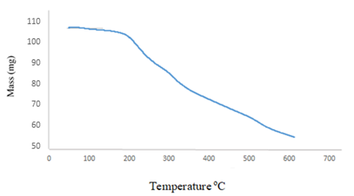
Fig. 3. TGA curve of BNPs@Si(CH₂)₃@NHSO3H nanocatalyst.

The of BNPs@Si(CH₂)₃@NHSO₃H nanocatalyst synthesized by EDX was studied. The presence of the elements C (16.69%), N (6.97%), O (55.76%), Al (18.41%), Si (0.97%) and S (1.19%) in the synthesized nanocatalyst structure were confirmed.

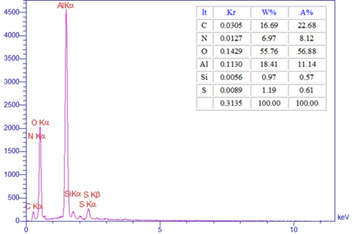
Fig. 4. EDX analysis of BNPs @ Si(CH₂)₃@NHSO₃H nanocatalyst.

The boehmite nanoparticles are identified by 2θ peaks at 13.82°, 17.68°, 20.63°, 23.22°, 38.54º, 52.55°. In the nanocatalyst XRD pattern, the peaks shown confirm the crystallization of the boehmite nanoparticles. It is clear that the structure of boehmite nanoparticles has not changed after its surface modification. Placing organic parts on the surface of BNPs leads to a change in the XRD pattern, as shown in the XRD pattern,, peaks that appear at 21.39°, 24.82°, 25.57°, 27.92°, 29.16° are related to boehmite-sulfonic acid and can confirm the synthesis of this new nanocatalyst.

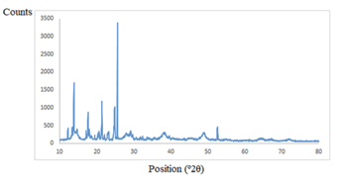
Fig. 5. The XRD pattern of BNPs @ Si(CH₂)₃@NH SO₃H nanocatalyst.

HNMR spectral data of compounds

¹HNMR and FTIR 5b:
Ethyl-2,7,7-trimethyl-4-(3-nitrophenyl)-5-oxo-1,4,5,6,7,8-hexahydroquinoline-3-carboxylate :
IR (KBr): 3276, 3191, 3074, 2964, 1703, 1604, 1642, 1488, 1379, 1278. 1H NMR (500 MHz, CDCl3): δH (ppm) = 0.93 (s, 3H, CH3), 1.09 (s, 3H, CH3), 1.19 (t, 3H, J = 7.15 Hz, CH3), 2.13-2.40 (m, 7H), 4.05 (q, 2H, J = 7.15 Hz, CH2), 5.15 (s, 1H, CH), 7.35-8.10 (ArH), 5.98 (s, 1H, NH); ¹³C NMR (100 MHz, DMSO): δ = 14.10, 18.28, 26.41, 29.06, 32.11, 35.56, 39.74, 50.16, 59.08, 103.11, 109.66, 127.66, 129.31, 130.18, 134.73, 145.39, 146.55, 149.58, 166.63, 194.23.

¹HNMR and FTIR 5d:
Ethyl-1,4,7,8-tetrahydro-2,7,7-trimethyl-4-(4-methoxylphenyl)-5(6H)-oxoquinolin-3-carboxylate:
IR (KBr): 3278, 3076, 2956, 1699, 1643, 1604, 1379. 1H NMR (500 MHz, CDCl3): δH (ppm) = 0.92 (s, 3H, CH3), 1.04 (s, 3H, CH3), 1.20 (t, 3H, J = 7.15 Hz, CH3), 1.74-2.33 (m, 4H, 2CH2), 3.71 (s, 3H, CH3), 4.06 (q, 2H, J = 7.15 Hz, CH2), 4.98(s, 1H, CH), 6.72 (d, 2H, ArH), 7.21 (d, 2H, ArH), 6.63 (s, 1H, NH); ¹³C NMR (100 MHz, DMSO): δ = 14.18, 18.25, 26.48, 29.17, 32.13, 34.78, 39.88, 50.32, 55.08, 58.95, 104.12, 110.34, 114.44, 128.33, 138.42, 144.38, 149.12, 155.24, 167.02, 194.29.

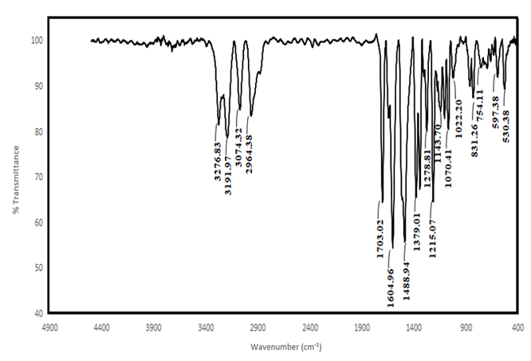

FT-IR spectrum of the Ethyl 2,7,7-trimethyl-4-(3-nitrophenyl)-5-oxo-1,4,5,6,7,8-hexahydroquinoline-3-carboxylate 5b

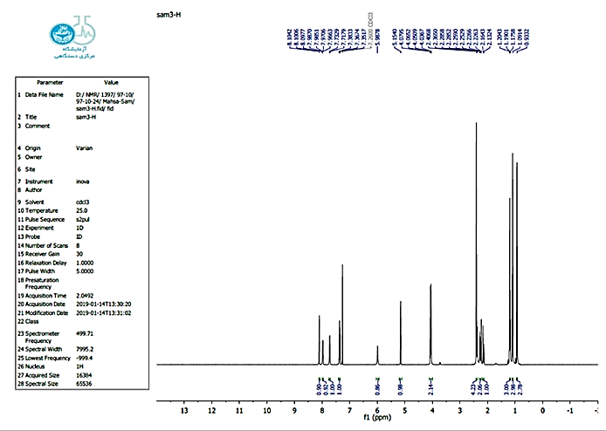
¹HNMR spectrum of the Ethyl 2,7,7-trimethyl-4-(3-nitrophenyl)-5-oxo-1,4,5,6,7,8-hexahydroquinoline-3-carboxylate 5b.
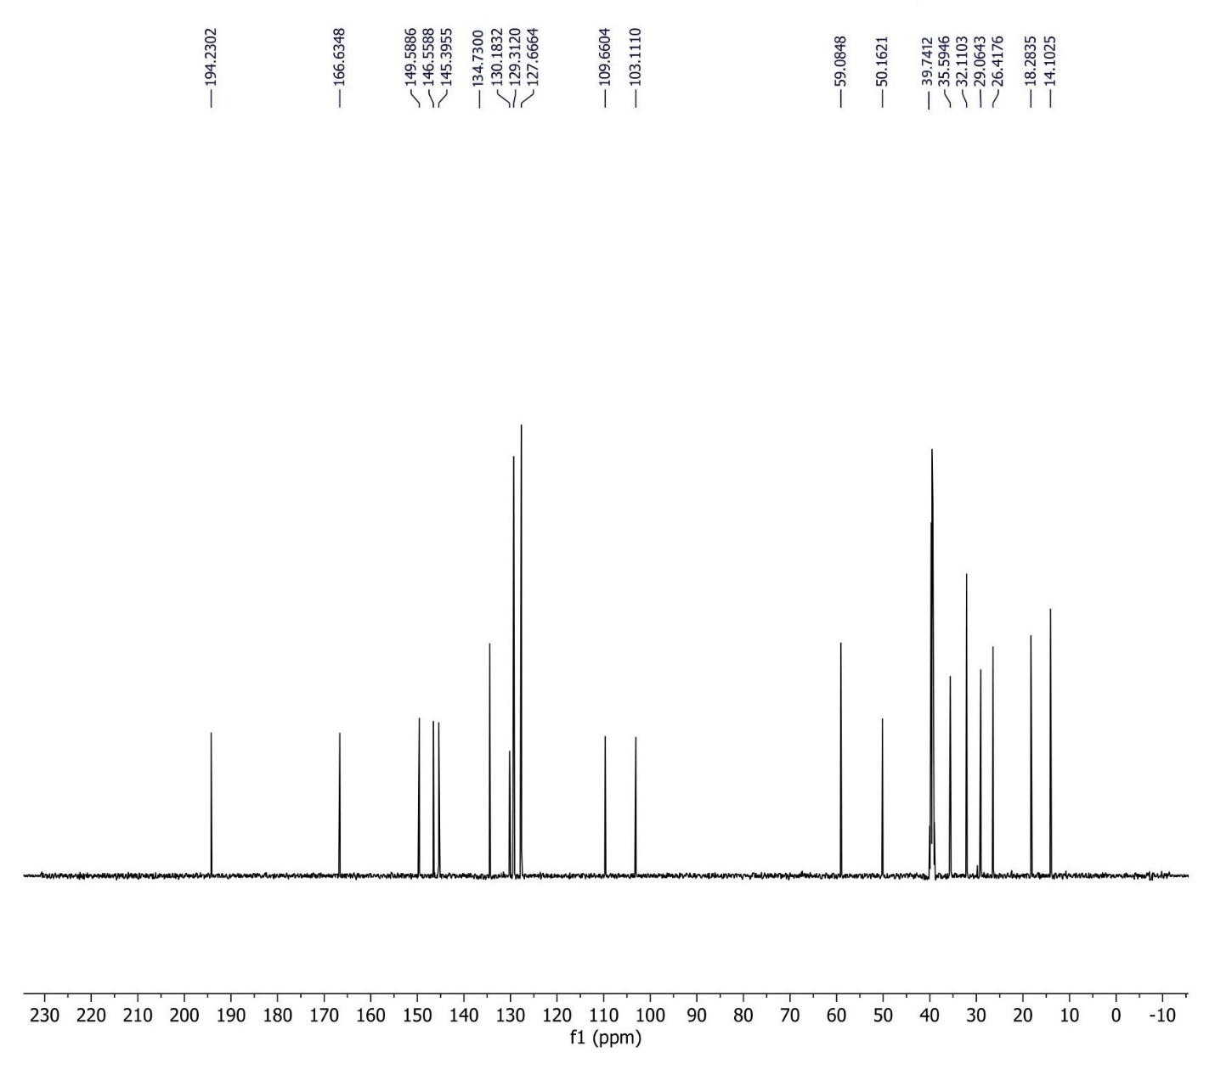

¹³C NMR spectrum of the Ethyl 2,7,7-trimethyl-4-(3-nitrophenyl)-5-oxo-1,4,5,6,7,8-hexahydroquinoline-3-carboxylate 5b

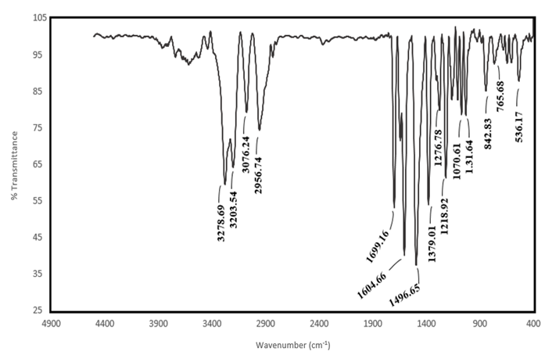
FT-IR spectrum of the Ethyl-1,4,7,8-tetrahydro-2,7,7-trimethyl-4-(4-methoxylphenyl)-5(6H)-oxoquinolin-3-carboxylate) 5d

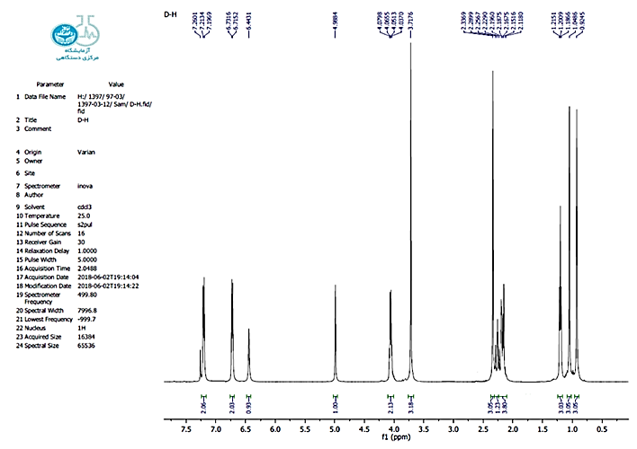
¹HNMR spectrum of the Ethyl-1,4,7,8-tetrahydro-2,7,7-trimethyl-4-(4-methoxylphenyl)-5(6H)-oxoquinolin-3-carboxylate) 5d

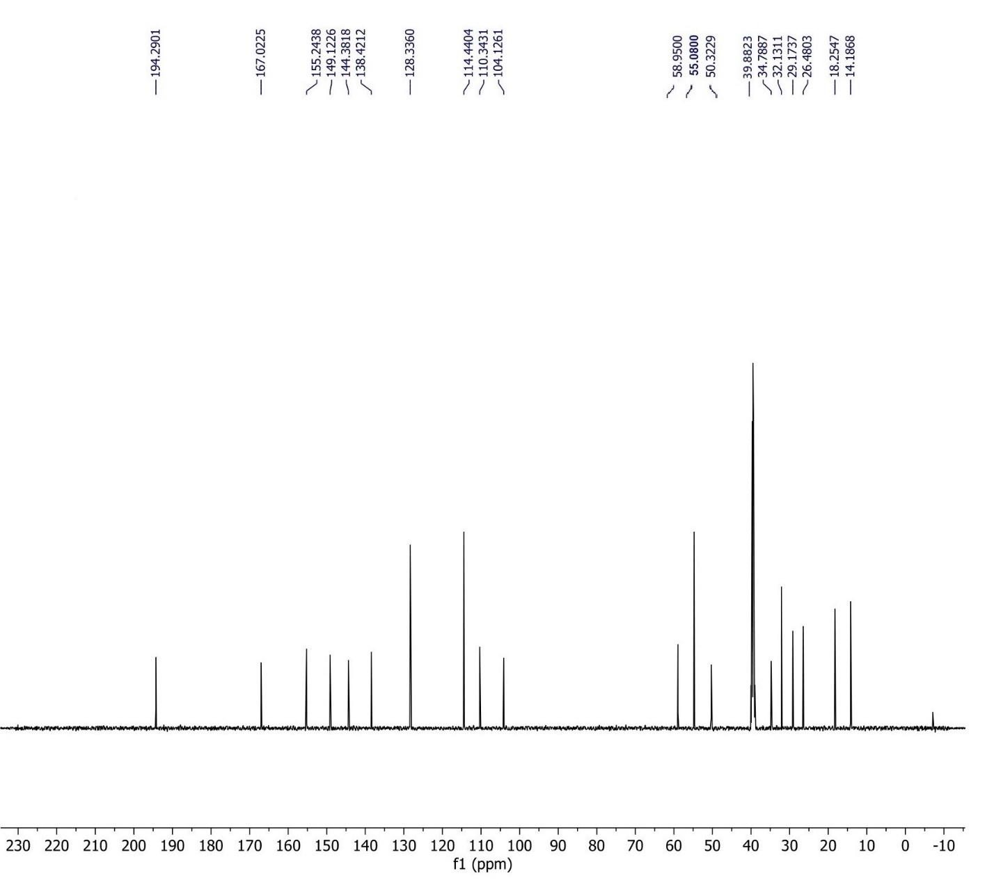
¹³C NMR spectrum of Ethyl-1,4,7,8-tetrahydro-2,7,7-trimethyl-4-(4-methoxylphenyl)-5(6H)-oxoquinolin-3-carboxylate) 5d

